
DATABASE SYSTEMS
AMPC402

Submitted by

HARISUDHAN B (I YEAR AIML)

REPORT



MANAKULA VINAYAGAR INSTITUTE OF TECHNOLOGY,
KALITHEERTHALKUPPAM, PUDUCHERRY, AN AUTONOMOUS INSTITUTION

BONAFIDE CERTIFICATE

This certifies that the following students studying year / VI semester have successfully completed the subject Design Thinking Laboratory during the academic year (25-26) in the EVEN semester.

Name of the Student
HARISUDHAN B

LAB - INCHARGE HEAD OF THE DEPARTMENT

Viva-Voce Examination held on..........................

INTERNAL EXAMINER EXTERNAL EXAMINER

CONTENT
S. NO | SECTION | DESCRIPTION
1 | Abstract | Overview of the project, objectives, and key features
2 | Introduction | Background, need, and purpose of the system
3 | Problem Statement | Issues in existing manual systems
4 | Objectives | Goals and expected outcomes of the project
5 | Scope of the System | Application areas and system capabilities
6 | ER Diagram | Entity-Relationship model of the system
7 | System Design | Architecture and module description
8 | Database Structure | Table design and field definitions
9 | Data Description | Explanation of stored data and structure
10 | Sample Data | Example records used in the system
11 | Python Logic / Operations | Core functionalities and implementation logic
12 | Explanation of Concepts | Key technologies used (Authentication, Blockchain, GitHub)
13 | Output | System results and functionalities
14 | Advantages | Benefits of the proposed system
15 | Limitations | Constraints and drawbacks
16 | Future Enhancements | Possible improvements and extensions
17 | Conclusion | Summary and outcome of the project
ORGAN TRANSPLANTATION MANAGEMENT SYSTEM

ABSTRACT
The Organ Transplantation Management System is a secure and efficient software application designed to manage organ transplant data digitally. It automates the process of storing, verifying, and retrieving critical medical information such as organ type, blood group, hospital details, and location. The system incorporates user authentication with role-based access control (Admin, Management, User) to ensure secure access. Data integrity is maintained using blockchain-inspired hashing techniques, where each record is linked with a previous hash to prevent tampering. Data is stored in structured CSV and JSON formats, and GitHub can be used for version-controlled storage. This system reduces manual effort, enhances transparency, and ensures reliable data management in healthcare environments.

INTRODUCTION
Organ transplantation is a critical medical procedure that requires accurate coordination and secure handling of sensitive data. Traditional systems rely on manual methods, which are time-consuming, error-prone, and lack proper security.
The Organ Transplantation Management System provides a digital solution to overcome these challenges. It enables secure storage, efficient retrieval, and verification of transplant data. The system uses modern technologies such as password hashing and blockchain-inspired validation to ensure data confidentiality and integrity.
The application is lightweight, easy to use, and suitable for hospitals and healthcare institutions.

PROBLEM STATEMENT
Manual organ transplant data management has several limitations:
- High risk of data loss and duplication
- Lack of data security
- Unauthorized access to sensitive information
- Difficulty in managing large datasets
- No mechanism to verify data integrity
This project addresses these issues by providing a secure, automated, and structured system.
OBJECTIVES
The primary objective of this system is to develop a secure and efficient platform for managing organ transplant data. The system ensures that only authorized users can access and manage records through authentication and role-based access control. It aims to store data in structured formats and maintain data integrity using blockchain-inspired hashing. The system also provides search and filtering capabilities for easy retrieval of records. Additionally, it integrates version control mechanisms to ensure transparency and data reliability.

SCOPE OF THE SYSTEM
The system can be used in:
- Hospitals
- Organ transplant centres
- Healthcare organizations
It supports:
- Multiple user roles
- Secure data storage
- Record verification
- Easy data retrieval and filtering

REVIEW OF LITERATURE
Modern healthcare systems increasingly rely on digital technologies to improve data management and security. Traditional database systems provide structured storage but lack mechanisms for tamper-proof data validation. Blockchain technology has emerged as a powerful solution for ensuring data integrity, as it links records using cryptographic hashes.
Studies show that hashing algorithms such as SHA-256 ensure that any modification in stored data can be detected easily. Authentication systems using B-Crypt improve security by protecting user passwords through hashing and salting techniques.
Cloud-based storage and version control platforms further enhance data reliability by maintaining history and backups. This project combines these concepts to develop a secure and efficient organ transplant management system.

ER DIAGRAM
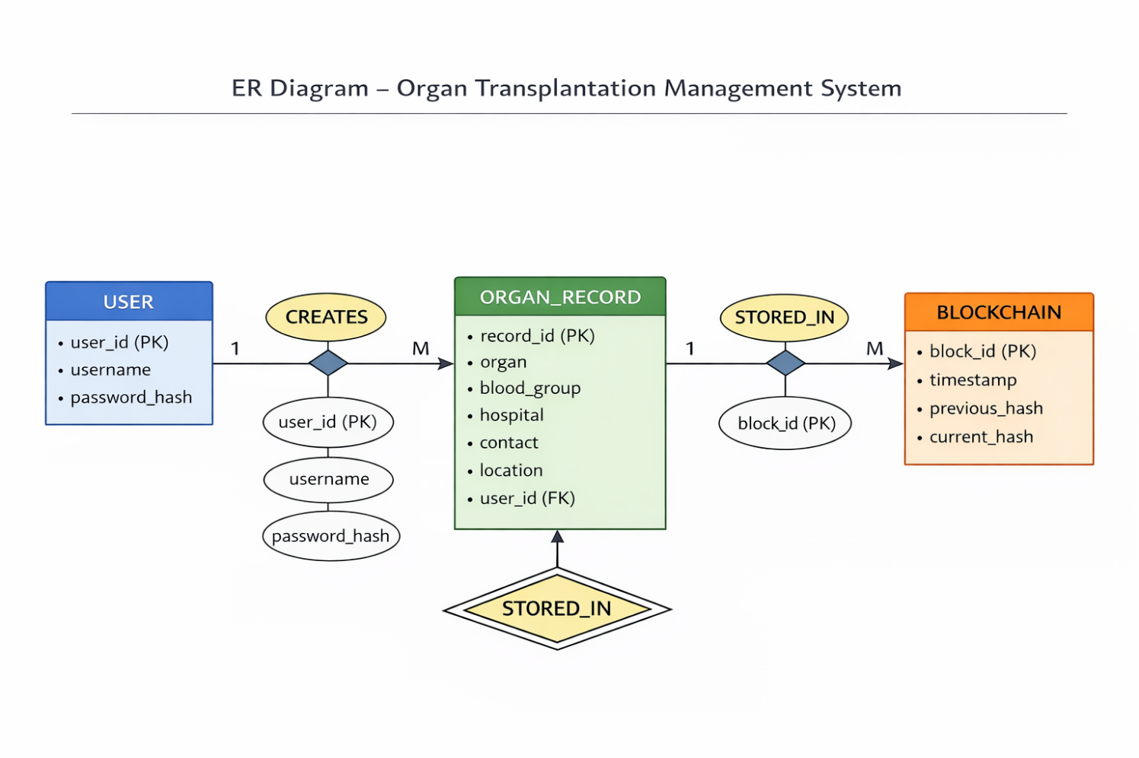
The system consists of three main entities: User, Organ Record, and Blockchain.
- The User entity stores login credentials and roles.
- The Organ Record entity stores transplant-related information such as organ type, blood group, hospital, contact, and location.
- The Blockchain entity stores hashed records to ensure data integrity.
A one-to-many relationship exists between User and Organ Record, as one user can create multiple records. Similarly, a one-to-many relationship exists between Organ Record and Blockchain, where each record is stored as a block.

SOURCE CODE
GitHub Repository: Organ Transplantation Management System
Sample data : organ_data.csv
Code: main.py

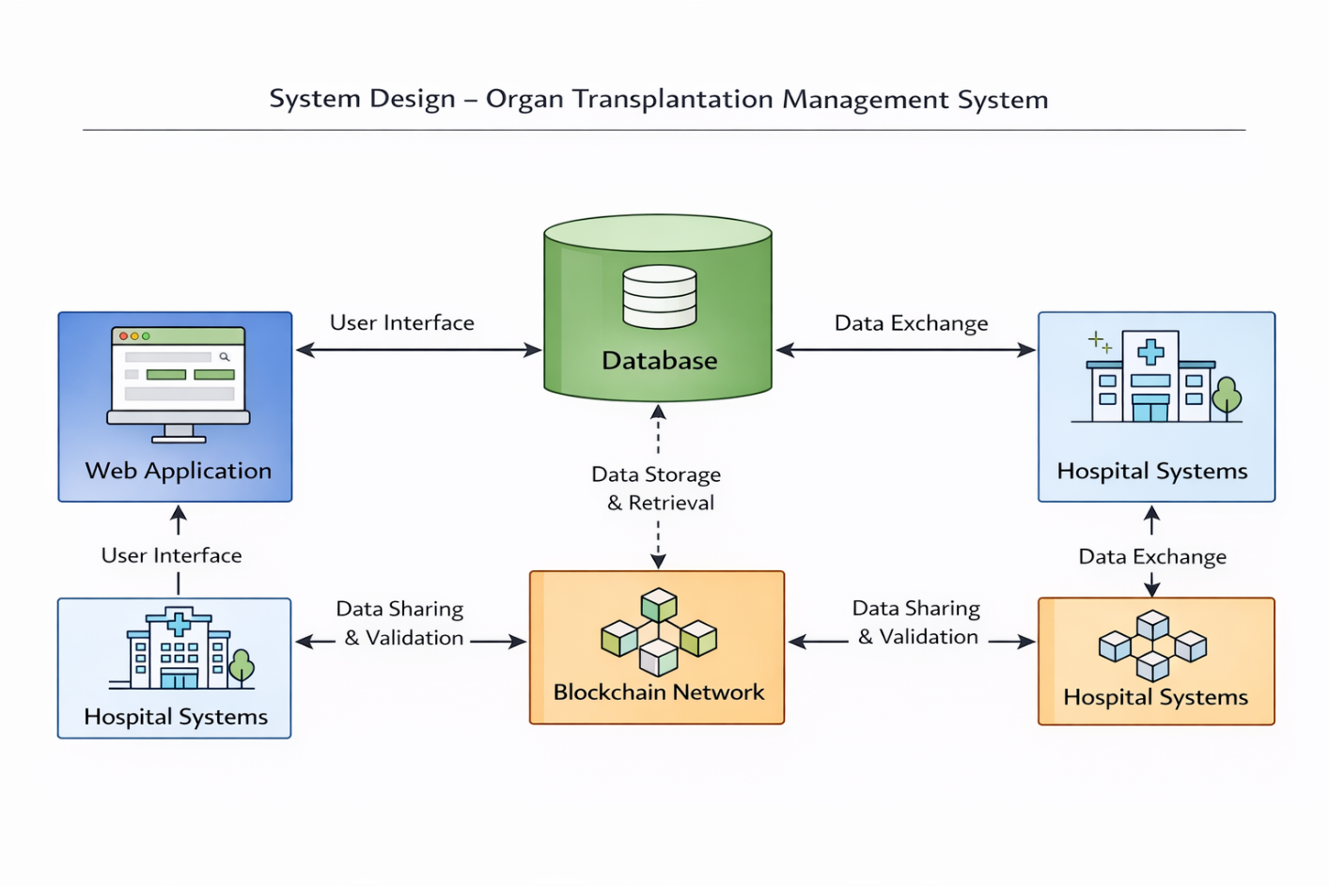
SYSTEM DESIGN
Overview
The system is designed using a modular approach with the following components:
- Authentication Module
- Data Management Module
- Blockchain Module
- Search Module
- Role-Based Access Module

Database Structure

Field Name | Data Type | Description
Record ID | INT | Unique record ID
Organ | VARCHAR | Organ type
Blood Group | VARCHAR | Blood group
Hospital | VARCHAR | Hospital name
Contact | VARCHAR | Contact number
Location | VARCHAR | Location

User Roles
- Admin: Full access including user management
- Management: Add and view records
- User: View and search records

DATA DESCRIPTION
Each record represents a transplant entry. The system stores multiple records and uses hashing to maintain integrity. Each new record is linked with the previous one.
SAMPLE DATA:
organ | hospital | blood group | contact | location
Kidney | Apollo | O+ | 9876543210 | Delhi
Liver | AIIMS | A+ | 9123456780 | Chennai
Heart | Fortis | B+ | 9988776655 | Mumbai
Kidney | CMC | O- | 9012345678 | Vellore

SYSTEM WORKFLOW
- User registers and logs in
- Role is verified (Admin/Management/User)
- User performs actions based on role
- Records are stored in CSV
- Blockchain hash is generated
- Data is saved in JSON
- Records can be searched or viewed

IMPLEMENTATION
The system is implemented using Python with the following features:
- B-Crypt for password hashing
- hashlib for SHA-256 hashing
- CSV for data storage
- JSON for blockchain and users
- CLI-based user interface

OUTPUT
The system provides:
- Secure login system
- Role-based menus
- Organ record management
- Blockchain verification
- Search and filtering functionality

ADVANTAGES
- Secure and reliable
- Prevents data tampering
- Easy to use
- Lightweight and scalable
- Reduces manual work

LIMITATIONS
- No graphical user interface
- Requires basic technical knowledge
- Manual GitHub integration

FUTURE ENHANCEMENTS
- Web-based application using Flask/Django
- Mobile application development
- AI-based organ matching system
- Real-time cloud database integration

CONCLUSION
The Organ Transplantation Management System provides a secure and efficient solution for managing sensitive medical data. By integrating authentication, blockchain-inspired hashing, and structured storage, the system ensures data integrity and confidentiality. It reduces manual effort and improves data accuracy. The system can be further enhanced with advanced features such as AI and web integration, making it a scalable solution for modern healthcare systems.

REFERENCES
- Calik, E., & Bendechache, M. (2024). Blockchain for organ transplantation: A survey. Blockchains, 2(2), 150–172.
- Bawa, G., Singh, H., Rani, S., Kataria, A., & Min, H. (2024). Exploring perspectives of blockchain technology and traditional centralized technology in organ donation management: A comprehensive review. Information, 15(11), 703.
- Panigrahi, R. R., Mukherjee, S., Shaikh, Z. H., & Nomran, N. M. (2025). Leveraging blockchain for transparency: A study on organ supply chains and transplant processes. Logistics, 9(1), 9.
- Singh, D., Monga, S., Tanwar, S., Hong, W.-C., Sharma, R., & He, Y.-L. (2023). Adoption of blockchain technology in healthcare: Challenges, solutions, and comparisons. Applied Sciences, 13(4), 2380.
- Assiri, B. (2023). A modified and effective blockchain model for e-healthcare systems. Applied Sciences, 13(23), 12630.
- Ghosh, S., & Dutta, M. (2023). Indriya: Building a secure and transparent organ donation system with Hyperledger Fabric. arXiv.
- Torongo, A. A., & Toorani, M. (2023). Blockchain-based decentralized identity management for healthcare systems. arXiv.
- Panda, K., & Mazumder, A. (2023). Blockchain-powered supply chain management for kidney organ preservation. arXiv.
- Etese, O., & Adesina, A.-A. (2025). A review and comparative analysis of password hashing techniques: Evaluating bcrypt and Argon2. SSRN Electronic Journal.
- Kuo, T.-T., & Zhang, P. (2023). Editorial: Blockchain and distributed ledger technology–enabled architectures for improving healthcare. Frontiers in Blockchain, 6, 1275474.
- Naresh, B., Pavani, C., Kiranmai, Y., Karthikeya, M., & Asheerawadam, J. (2026). AI-based organ health analysis for organ donation management with blockchain. International Journal of Engineering Research and Science & Technology, 22(2), 110–127.
- Shymala, B., Solana, M., Saranya, P., & Swetha, M. (2023). Organ donation and transplantation framework based on Ethereum blockchain. In Proceedings of the International Conference on Innovative Computing & Communication (ICICC 2022).

